MODULE : 01 (SDLC)
01)What is software? What is software engineering?
ANS:
Software is basically a set of instructions (programs) that tell a computer what to do and how to do it.
Software Engineering is the process of designing, developing, testing, and maintaining software using proper methods and principles.

02) Explain types of software
ANS:
- System Software – Runs the computer
(e.g., Operating Systems like Windows)
- Application Software – Helps users perform tasks
(e.g., MS Word, Calculator)
03) Utility Software – Maintains the system
(e.g., antivirus, disk cleanup)

03) What is SDLC? Explain each phase of SDLC
ANS:
SDLC (Software Development Life Cycle) is a step-by-step process used to develop high-quality software in a systematic way.
Phase
Planning : Decide what to build
Requirement Analysis : Collect user needs
Design : Plan structure & UI
Implementation (Coding) : Write code
Testing : Find & fix errors
Deployment : Release software
Maintenance : Update & improve

04) What is DFD? Create a DFD diagram on Flipkart
ANS:
DFD (Data Flow Diagram) is a graphical representation of how data flows inside a system.
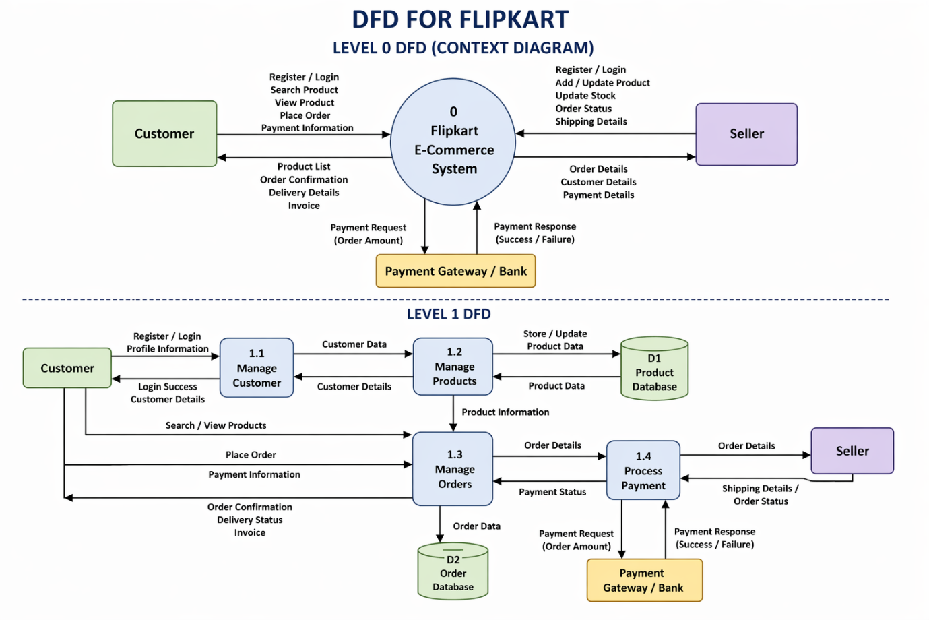

05) What is Flow chart? Create a flowchart to make addition of two numbers
ANS:
A Flowchart is a graphical representation of steps (algorithm) used to solve a problem.

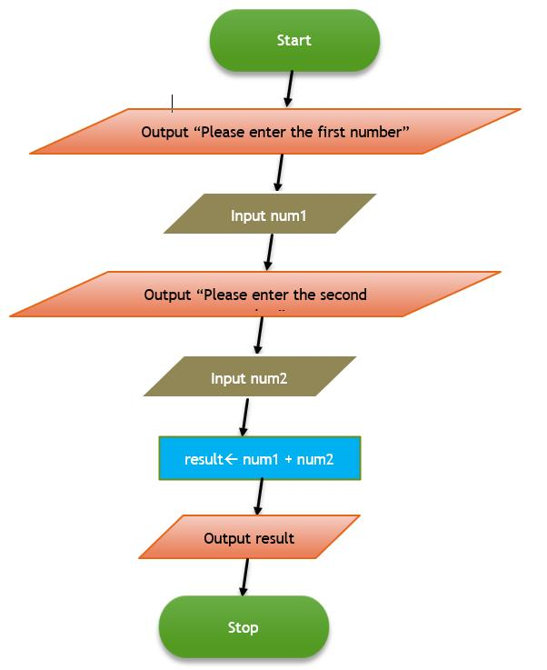

06) What is Use case Diagram? Create a use-case on bill payment on paytm.
ANS:
A Use Case Diagram is a type of diagram in Unified Modeling Language (UML) that shows how users (actors) interact with a system.
